Medical Genetics stage:3
Dr. Noor M. Awad lec: 12
Sex influenced traits and Sex limited genes

1-Introduction
Sex influenced traits appear more often in one sex than the other. Although these traits may appear more often in males than in females, they are not sex linked, because they do not appear on the sex chromosomes. The genes for sex-influenced traits are on the autosomes not the sex chromosomes. Sex influenced traits are influenced by both genes and hormones, not just genes. As a result, an allele in one sex can be dominant because of the interactions between genes and hormones, while the same gene in the other sex is recessive because they do not have the same hormone interactions.
2: Sex Influenced Traits examples A-Baldness in human
It may occur in some cases, due to disease or other environmental factors, but is of generally a hereditary character, which is more prevalent in men, than in women. Studies on the mode of inheritance of baldness have shown that it is not inherited in the same way as the recessive sex-linked genes.
It cannot be due to a dominant sex-linked gene, because more women than men are not bald. It has been shown that baldness is due to peculiar genes,
called sex-influenced genes. The character is dominant in men and recessive in women.
A man is bald if he has only one gene for baldness, but a woman is bald if two genes are present. If ‘B’ presents a gene for baldness and ‘b’ for non- baldness, and the sex- influences is such that ‘B’ is dominant in man, and recessive in woman, the genotypes of various individuals will be :BB= Bald

in male and female, Bb= Bald in male only, bb= Normal both male and female

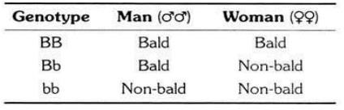

This table illustrates genotype and phenotype in baldness
Hormone: Testosterone is responsible for the phenotypic expression of the

different alleles. In males, the testosterone causes the allele for baldness to be dominant over the normal allele whereas in females, the minimal amount of testosterone has the opposite effect.
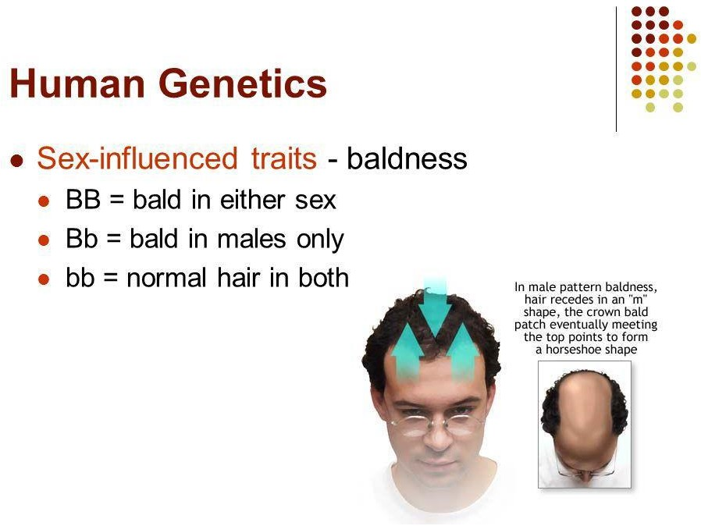

3:Sex Limited Traits
Sex-limited genes are genes that are present in both sexes of sexually reproducing species but are expressed in only one sex and remain 'turned off' in the other. In other words, sex-limited genes cause the two sexes to show different traits or phenotypes, despite having the same genotype. Sex-limited
genes are also distinguished from sex-influenced genes, where the same gene will show differential expression in each sex. Sex-influenced genes commonly show a dominant/recessive relationship, where the same gene will have a dominant effect in one sex and a recessive effect in the other (for
example, male pattern baldness).
Beard development in human beings is a sex limited trait as men normally have beards, whereas women normally do not. Likewise, the genes for male voice, body hair and physique are autosomal in human beings, but they are expressed only in the presence of androgens which are absent in females.

